# Abstract

# Introduction

# Inverse kinematics

# Robot design

# End effector design

## Iteration 1 – Parallel gripper fingers

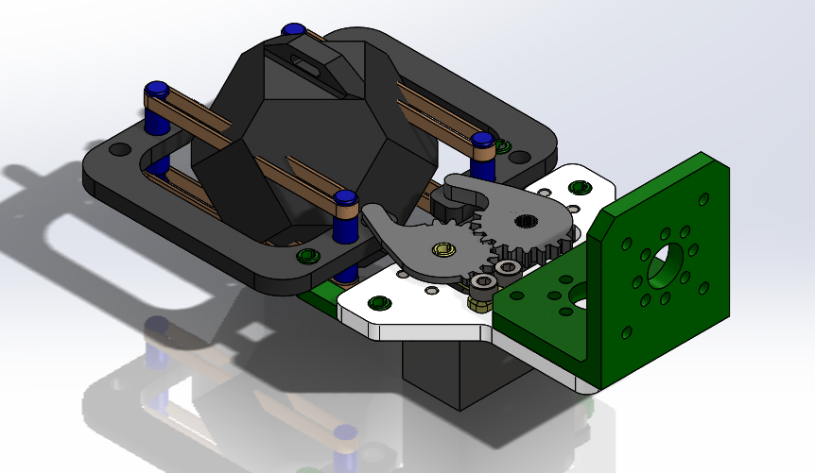

Figure : Gripper iteration 1

## Iteration 2 – Parallel, vertically oriented fingers

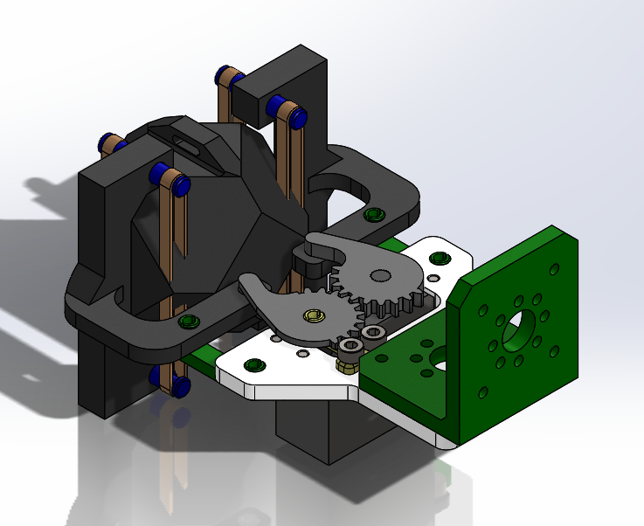

Figure : Gripper iteration 2

# Performance

## Attempt 1

A little slow but on target. Probably due to sub-optimal path design, but primarily due to the lack of closed loop feedback. The program had no way of determining when the robot had actually reached a requested position and relied instead on delays.

## Attempt 2

Fresh batteries and disparate servo speeds doomed this round as the end-effector pushed the payload out of the pickup zone on its approach. The crash also resulted in substantial gripper finger damage which would have precluded any additional attempts if we had gotten them.

# Code

The original pathfinding algorithm that was developed was not used. It seemed that there was a version conflict or some other un-diagnosed bug when translating from one machine to another. However, it is included here to document the intended functionality of the project.

Subsequently, Sanitize inputs.py was included as the other dependency of our program. This was used in the final result for error checking and sanitizing input data from the user. It also assisted with proper numpy array syntax.

## Astar.py

import sanitize_inputs as si

import numpy as np

class obstacle():

def __init__(self, location, radius, height=float('Inf')):

self.loc = location

self.r = radius

self.h = height

self.d = (self.loc.x**2+self.loc.y**2)**0.5

#The following calculates the angular 'shadow' cast by the object

self.beta = np.arctan2(self.loc.y, self.loc.x)

self.theta = np.arcsin(self.r/self.d)

self.angle1 = self.beta + self.theta

self.angle2 = self.beta - self.theta

def collision_detect(self, point):

'''This function accepts a column vector and checks if it collides with

the obstacle object.'''

d = ((self.loc.x-point.loc.x)**2

+ (self.loc.y-point.loc.y)**2)**0.5

if ((self.loc.z <= point.loc.z <= self.loc.z + self.h)

and d <= self.r):

return(True)

else:

return(False)

def robot_collision_detect(self, point):

d = ((point.loc.x)**2

+ ((point.loc.y))**2)**0.5

beta = np.arctan2(point.loc.y, point.loc.x)

if d >= self.d - self.r and self.angle2 < beta < self.angle1:

return(True)

else:

return(False)

class node():

def __init__(self, location):

self.loc = location

def open_node(self, gcost, hcost, parent=None):

self.parent = parent

if parent != None:

self.parent_g_cost = parent.gcost

else:

self.parent_g_cost = 0

self.gcost = self.parent_g_cost + gcost

self.hcost = hcost

self.fcost = self.gcost + self.hcost

def print_node(self):

print("X: ",self.loc.x,

"Y: ",self.loc.y,

"Z: ",self.loc.z,

"\nG-cost: ",self.gcost,

"\nH-cost: ",self.hcost,

"\nF-cost: ",self.fcost,sep='')

print("\n")

def set_walkable(self, walk=True):

'''If walk is True, the node is reachable, and is not blocked by an

obstacle.'''

self.walk = walk

class work_envelope():

def __init__(self, x_dim, y_dim, z_dim, dx=1, dy=1, dz=1):

self.dx = dx

self.dy = dy

self.dz = dz

self.x_dim = x_dim

self.y_dim = y_dim

self.z_dim = z_dim

self.open_nodes = []

self.closed_nodes = []

self.obstacles = []

def dist(self,n1, n2):

d = (((n1.loc.x-n2.loc.x))**2

+ ((n1.loc.y-n2.loc.y))**2

+ ((n1.loc.z-n2.loc.z))**2)**0.5

return(d)

def check_match(self, n1, n2):

'''This function checks whether the coordinates of two given nodes

match, and thereby whether one is a duplicate of the other.'''

epsilon = 0.01

if (abs(n1.loc.x - n2.loc.x) < epsilon

and abs(n1.loc.y - n2.loc.y) < epsilon

and abs(n1.loc.z - n2.loc.z) < epsilon):

match = True

else:

match = False

return(match)

def check_existence(self, n, gcost):

'''This function checks for the existence of a given node, n,

in the open_nodes and closed_nodes lists.'''

exists = False

for elem in self.open_nodes:

exists = self.check_match(elem, n)

if exists:

elem.gcost = min(gcost, elem.gcost)

break

else:

pass

for elem in self.closed_nodes:

exists = self.check_match(elem, n)

if exists:

break

else:

pass

return exists

def check_collision(self, node):

collides = False

for o in self.obstacles:

collides = o.robot_collision_detect(node)

if collides:

break

return(collides)

def new_node(self, gcost, new, end, n):

exists = self.check_existence(new, gcost)

if exists == False:

hcost = self.dist(new, end)

if (self.check_collision(new)):

self.closed_nodes.append(new)

else:

new.open_node(gcost, hcost, n)

self.open_nodes.append(new)

else:

pass

def close_node(self, n, end):

# temporary variables for current node

x = n.loc.x

y = n.loc.y

z = n.loc.z

# Explore x dimension

gcost = self.dx

new = node(si.col_vec([x-self.dx,y,z]))

self.new_node(gcost, new, end, n)

new = node(si.col_vec([x+self.dx,y,z]))

self.new_node(gcost, new, end, n)

# Explore y dimension

gcost = self.dy

new = node(si.col_vec([x,y-self.dy,z]))

self.new_node(gcost, new, end, n)

new = node(si.col_vec([x,y+self.dy,z]))

self.new_node(gcost, new, end, n)

# Explore z dimension

gcost = self.dz

new = node(si.col_vec([x,y,z-self.dz]))

self.new_node(gcost, new, end, n)

new = node(si.col_vec([x,y,z+self.dz]))

self.new_node(gcost, new, end, n)

# Explore xy diagonals

gcost = (self.dx**2 + self.dy**2)**0.5

new = node(si.col_vec([x-self.dx,y-self.dy,z]))

self.new_node(gcost, new, end, n)

new = node(si.col_vec([x-self.dx,y+self.dy,z]))

self.new_node(gcost, new, end, n)

new = node(si.col_vec([x+self.dx,y-self.dy,z]))

self.new_node(gcost, new, end, n)

new = node(si.col_vec([x+self.dx,y+self.dy,z]))

self.new_node(gcost, new, end, n)

# Explore yz diagonals

gcost = (self.dy**2 + self.dz**2)**0.5

new = node(si.col_vec([x,y-self.dy,z-self.dz]))

self.new_node(gcost, new, end, n)

new = node(si.col_vec([x,y+self.dy,z-self.dz]))

self.new_node(gcost, new, end, n)

new = node(si.col_vec([x,y-self.dy,z+self.dz]))

self.new_node(gcost, new, end, n)

new = node(si.col_vec([x,y+self.dy,z+self.dz]))

self.new_node(gcost, new, end, n)

# Explore xz diagonals

gcost = (self.dx**2 + self.dz**2)**0.5

new = node(si.col_vec([x-self.dx,y,z+self.dz]))

self.new_node(gcost, new, end, n)

new = node(si.col_vec([x-self.dx,y,z-self.dz]))

self.new_node(gcost, new, end, n)

new = node(si.col_vec([x+self.dx,y,z+self.dz]))

self.new_node(gcost, new, end, n)

new = node(si.col_vec([x+self.dx,y,z-self.dz]))

self.new_node(gcost, new, end, n)

# Explore corners

gcost = (self.dx**2 + self.dy**2 + self.dz**2)**0.5

new = node(si.col_vec([x-self.dx,y-self.dy,z-self.dz]))

self.new_node(gcost, new, end, n)

new = node(si.col_vec([x-self.dx,y-self.dy,z+self.dz]))

self.new_node(gcost, new, end, n)

new = node(si.col_vec([x-self.dx,y+self.dy,z-self.dz]))

self.new_node(gcost, new, end, n)

new = node(si.col_vec([x-self.dx,y+self.dy,z+self.dz]))

self.new_node(gcost, new, end, n)

new = node(si.col_vec([x+self.dx,y-self.dy,z-self.dz]))

self.new_node(gcost, new, end, n)

new = node(si.col_vec([x+self.dx,y-self.dy,z+self.dz]))

self.new_node(gcost, new, end, n)

new = node(si.col_vec([x+self.dx,y+self.dy,z-self.dz]))

self.new_node(gcost, new, end, n)

new = node(si.col_vec([x+self.dx,y+self.dy,z+self.dz]))

self.new_node(gcost, new, end, n)

self.closed_nodes.append(self.open_nodes.pop(0))

def sort_nodes(self):

self.open_nodes.sort(key=lambda x: x.fcost, reverse=False)

def generate_obstacle(self, obstacle):

'''Append an obstacle to the work envelope's list of obstacles.'''

self.obstacles.append(obstacle)

def generate_path(start, goal, n, *obstacles):

'''This function generates a path given a starting location, a goal

location, and an arbitrary number of obstacles.'''

epsilon = 0.25

dx = abs(goal.loc.x-start.loc.x)/n

dy = abs(goal.loc.y-start.loc.y)/n

dz = abs(goal.loc.z-start.loc.z)/n

print("dx: ",dx,"dy: ",dy,"dz: ",dz,sep='')

w_env = work_envelope(1, 1, 1, dx, dy, dz)

path_complete = False

for o in obstacles:

w_env.generate_obstacle(o)

start_node = start

goal_node = goal

start_h_cost = w_env.dist(start_node, goal_node)

start_node.open_node(0, start_h_cost, parent=None)

w_env.open_nodes.append(start_node)

try:

while path_complete == False:

w_env.sort_nodes()

if w_env.check_match(w_env.open_nodes[0], goal_node):

print("Found the end.")

path = [w_env.open_nodes[0]]

while (path[-1].parent != None):

path.append(path[-1].parent)

print("Finished the path")

print("Opened",len(w_env.open_nodes),"nodes.")

print("Closed",len(w_env.closed_nodes),"nodes.")

break

w_env.close_node(w_env.open_nodes[0], goal_node)

## print("Open nodes: ", len(w_env.open_nodes))

## print("Closed nodes: ", len(w_env.closed_nodes))

except IndexError:

print("All nodes opened.")

path_mat = np.array([goal_node.loc.x, goal_node.loc.y, goal_node.loc.z])

for elem in path:

path_mat = np.row_stack([[elem.loc.x, elem.loc.y, elem.loc.z], path_mat])

## elem.print_node()

return(path_mat)

## Sanitize inputs.py

import numpy as np

class col_vec():

'''Retrieves a list of real number for x, y, and z from the user,

and constructs a numpy column vector.'''

def __init__(self, coords):

self.x = coords[0]

self.y = coords[1]

self.z = coords[2]

self.vec = np.array([[self.x],[self.y],[self.z]])

def get_real_number(prompt=None, upper=float('Inf'), lower=float('-Inf')):

'''Gets a real number from the user with an optional prompt. Positive and

negative limits can be set. If not set, the default values are 'Inf' and

'-Inf' respectively.'''

num_flag = False

while(not num_flag):

try:

number = float(input(prompt))

if lower < number < upper:

num_flag = True

else:

print("Enter a real number between",lower,"and",upper)

except ValueError:

print("Enter a real number.")

num_flag = False

return(number)

def get_integer(prompt=None, upper=float('Inf'), lower=float('-Inf')):

'''Gets an integer from the user with an optional prompt. Positive and

negative limits can be set. If not set, the default values are 'Inf' and

'-Inf' respectively.'''

num_flag = False

while(not num_flag):

try:

number = int(input(prompt))

number += 0

# This will throw an exception if number is not an integer.

if lower < number < upper:

num_flag = True

else:

print("Enter a real number between",lower,"and",upper)

except ValueError:

print("Enter an integer.")

num_flag = False

return(number)

def get_letter(prompt=None, accept=None):

# Gets a single alpha character that is included in the list 'accept'

# Optionally include a prompt to the user

# omitting the accept list allows all alpha characters.

flag = False

while(not flag):

letter = str(input(prompt))

if(letter.isalpha() and len(letter) == 1):

if accept != None:

for i in accept:

if letter == i or accept==None:

flag = True

break

else:

pass

else:

flag = True

else:

pass

return(letter)

def get_coords(rows=3):

'''This function gets the coordinates for a point in 3D space from the user.

It includes the error checking logic required to ensure the point's

useability in subsequent functions.'''

P_x = get_real_number("X >>> ")

P_y = get_real_number("Y >>> ")

P_z = get_real_number("Z >>> ")

point = col_vec([P_x,P_y,P_z])

if rows == 3:

return(point)

elif rows == 4:

point.vec = np.row_stack([point.vec,[1]])

return(point)

else:

print("Invalid argument.")

return(None)